STAT301 Worksheet 5 Name
- The attractiveness of a person’s face is traditionally considered to be related to physical features, such as how symmetrical the features are, and how close a face is to the “average” face over many people. However, there is also evidence that perceived facial attractiveness can vary due to factors outside of the face. In what has become known as the “cheerleader effect”, the same face is perceived to be more attractive when seen in a group, as compared to when it is seen alone.
Carragher, Thomas, Gwinn, & Nicholls (2019) set out to test this hypothesis. In one part of their study (Experiment 1), they let participants rate the attractiveness of a face when presented by itself (the Alone condition), as part of a group of different faces (the Different condition), and as part of a group of similar faces (the Similar condition).
Perform a hypothesis test to see whether the mean attractiveness scores are significantly different among the three conditions using the significance level of 0.05.
Individual | Alone | Different faces in a group | Similar faces in a group
1 | 56.3 | 55.9 | 54.3
2 | 49.8 | 49.7 | 51.2
3 | 47.1 | 52.5 | 53.2
4 | 38.9 | 41.6 | 42.1
5 | 44.7 | 47.0 | 50.5
6 | 45.2 | 43.9 | 46.2
7 | 36.8 | 37.3 | 38.8
8 | 53.8 | 52.7 | 53.9
9 | 45.1 | 46.2 | 49.1
a) Formulate the null and alternative hypotheses

b) What is the test statistic and p-value?

c) What decision can you make to $H_{0}$. Explain your decision in the context

f) if there is a significant difference, which two conditions are significantly different?

2. We would like to conduct a survey to investigate excessive coffee drinking. We took a sample of 10 individuals and surveyed how many cups of coffee they drink in the morning and how many they drink in the afternoon. We also would like to know the volume of the cups (8oz, 12oz, or 16oz). The data on the worksheet is what we obtained from the 10 individuals in one day. Perform an appropriate analysis to investigate whether people drink significant different amount of coffee between morning and afternoon, whether there are significant effects from the types of cups and if there is any interaction between time and type of cups.
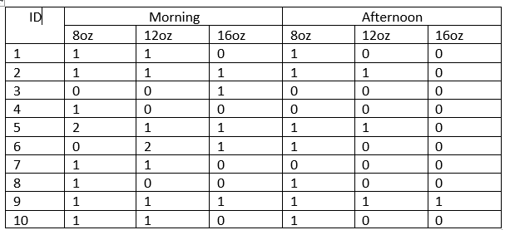
- What is the F and p-value for testing the main effect of time?

- What decision can you make for the main effect of time?

- What is the F and p-value for testing the main effect of coffee cup size?

- What decision can you make for the main effect of coffee cup size?

- What can you conclude about significance of the interaction? What is the p-value?

